Autumn 2022

Dmitry Semenov

[dsemenov@uef.fi](mailto:dsemenov@uef.fi)

+358-50-3043941

**Name: Amrit Shaw**

**Group 5**

**Tasks #1. Freelook and spectral files.**

1. **Download from your google drive**

1.1 Download Freelook viewer for ENVI spectral files (in Lectures+Exercises\LectureExercise #5, Freelook and bmp\Codes and software): **freelokk43.zip**

1.2 Download spectral files (Lectures+Exercises\LectureExercise #5, Freelook and bmp):

1. **Colorchecker 121 ms**
2. **Leaves (Specim IQ)\006 (Select 750 nm for the Red channel)**
3. **Infrared (by** [**sarita.keski-saari@uef.fi**](mailto:sarita.keski-saari@uef.fi)**)**
4. **124 (rock painting)**

Downloaded the freelook viewer and the spectral files.

Size of all spectral files together can be several gigabytes

1.3 Try to open spectral images with Freelook as we did on lecture. Load the preview as:

* gray-scale:

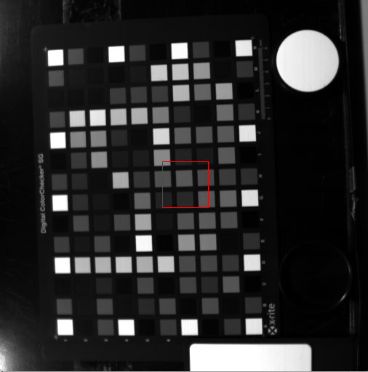

Band 57: 560 nm

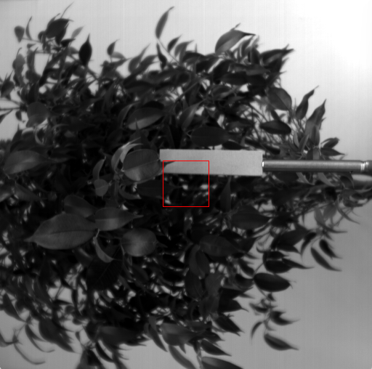

Band 56: 557nm

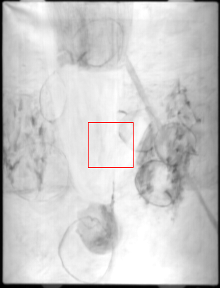

Band 50: 1231

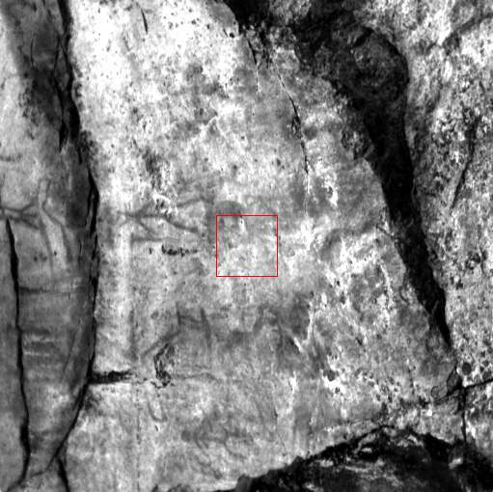

Band 57: 560

* RGB (using spectral bands RED 630 nm, Green 530 nm, Blue 430 nm)

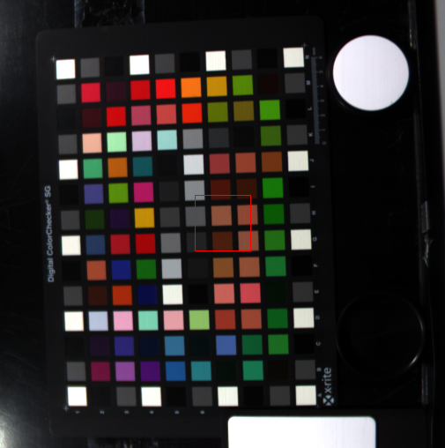

Band 81: 631.1500; Band 47: 530.9600; Band 13 :431.9700

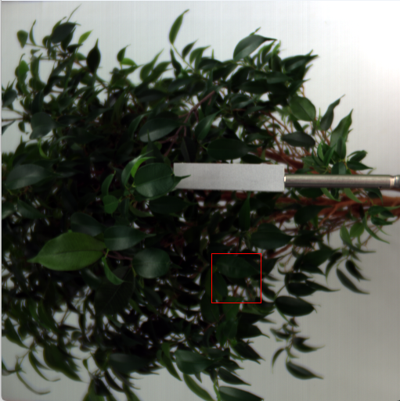

Band 81: 631.1500; Band 47: 530.9600; Band 12: 429.0800

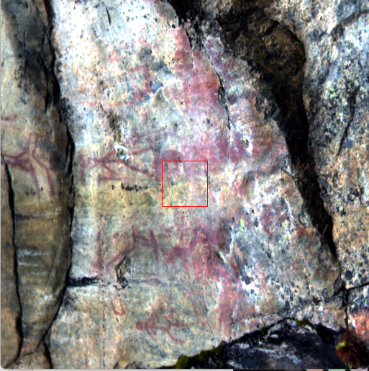

Band 81: 631.1500; Band 47: 530.9600; Band 12: 429.0800

* RGB using other spectral bands (use IR channel of 800 nm instead if 630 nm for Leaves)

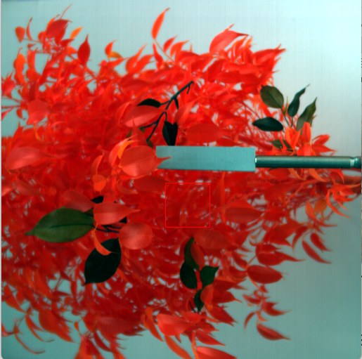

Band 138: 801.7900; Band 47: 530.9600; Band 12: 429.0800

* Check spectra of different color-patches in Colorchecker

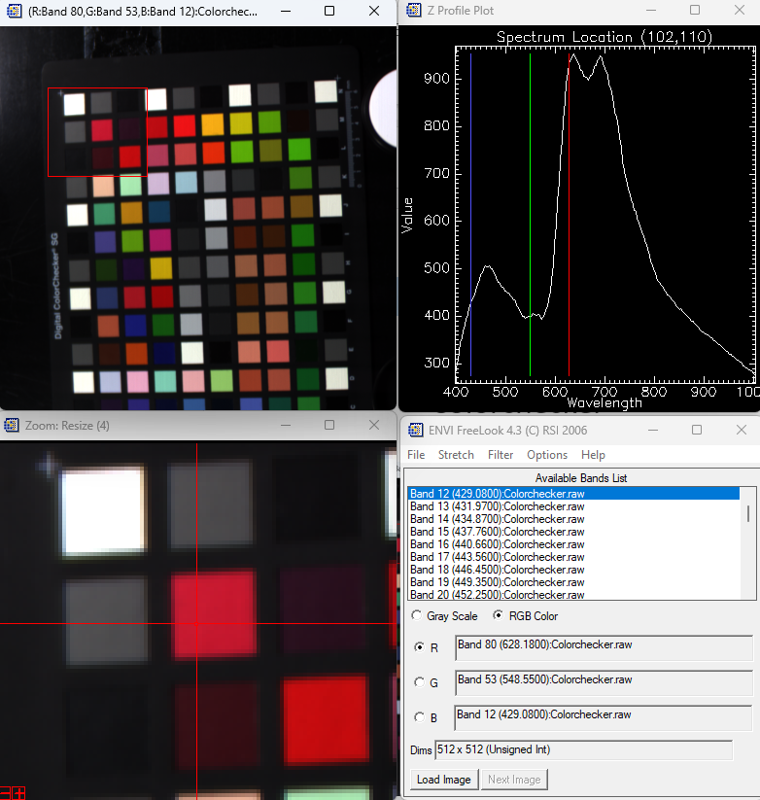

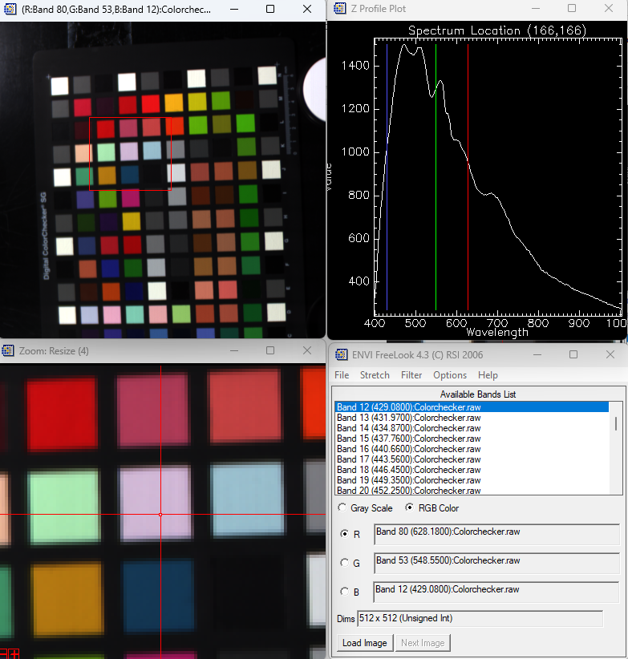

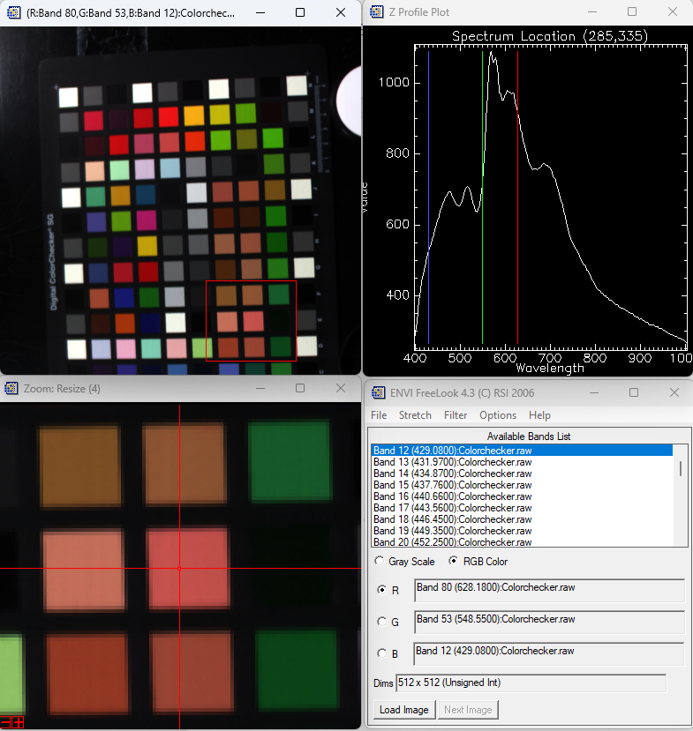

* In “Leaves (Specim IQ)” make plastic leaves “visible” as we did on lectures

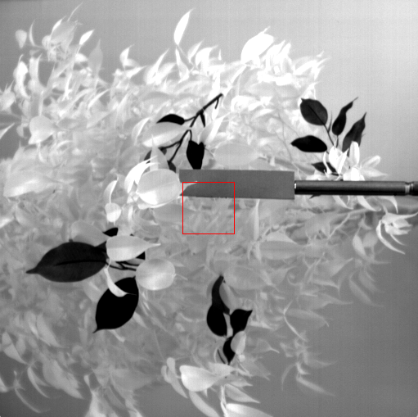

Band 127: 768nm

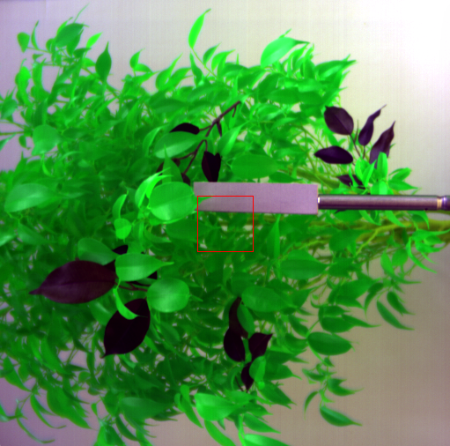

Band 96: 675; Band 57:560; Band 5: 408

* The image “Infrared by sarita.keski-saari@uef.fi” is an IR image. Play with bands and show that we see the second image below the first on the top

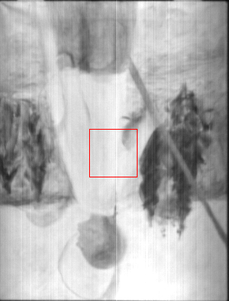

Band 15: 1008nm (top picture of an Inverted human is visible)

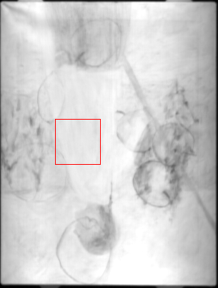

Band 48: 1218nm (As higher wavelength band is selected, the lower picture gets visible slowly)

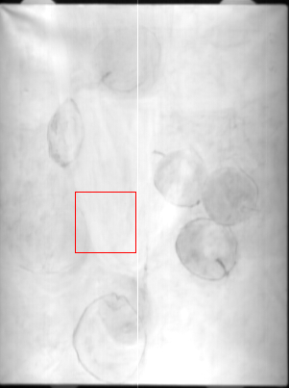

Band 163: 1943nm (in this higher wavelength band we can visualize the lower picture)

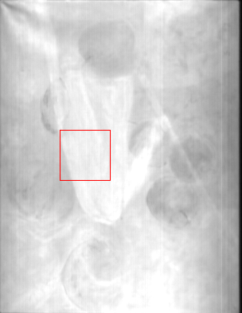

Band 204: 2202nm (at much higher wavelength the contrast between the two picture reduces)

* With image “124 (rock painting)” play with spectral bands and check whether all bands are equal for visibility of rock painting.

After comparing different bands as RGB, this picture seemed to me as the one mostly differentiating the colours in the rock.

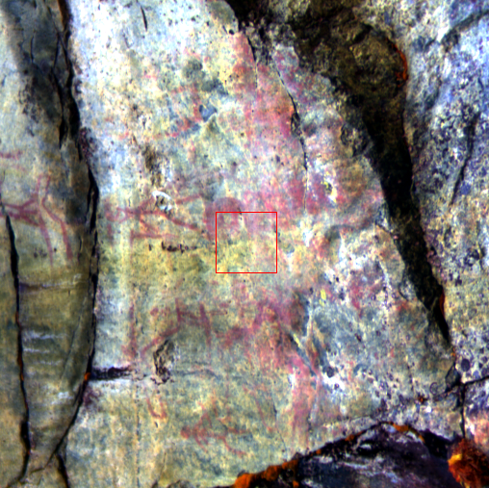

Band 106:680nm; Band 57: 560nm; Band 5: 408nm

**Tasks #2. Study csv spectra of different materials**

**Shared csv files are in folder Lectures+Exercises\LectureExercise #1, CSV\csv files**

**Colab codes are in Lectures+Exercises\LectureExercise #1, CSV\codes**

In the picture below (shared ‘**Collection of samples.jpg’**) you can see collection of different materials. About 100 different materials of different colors.

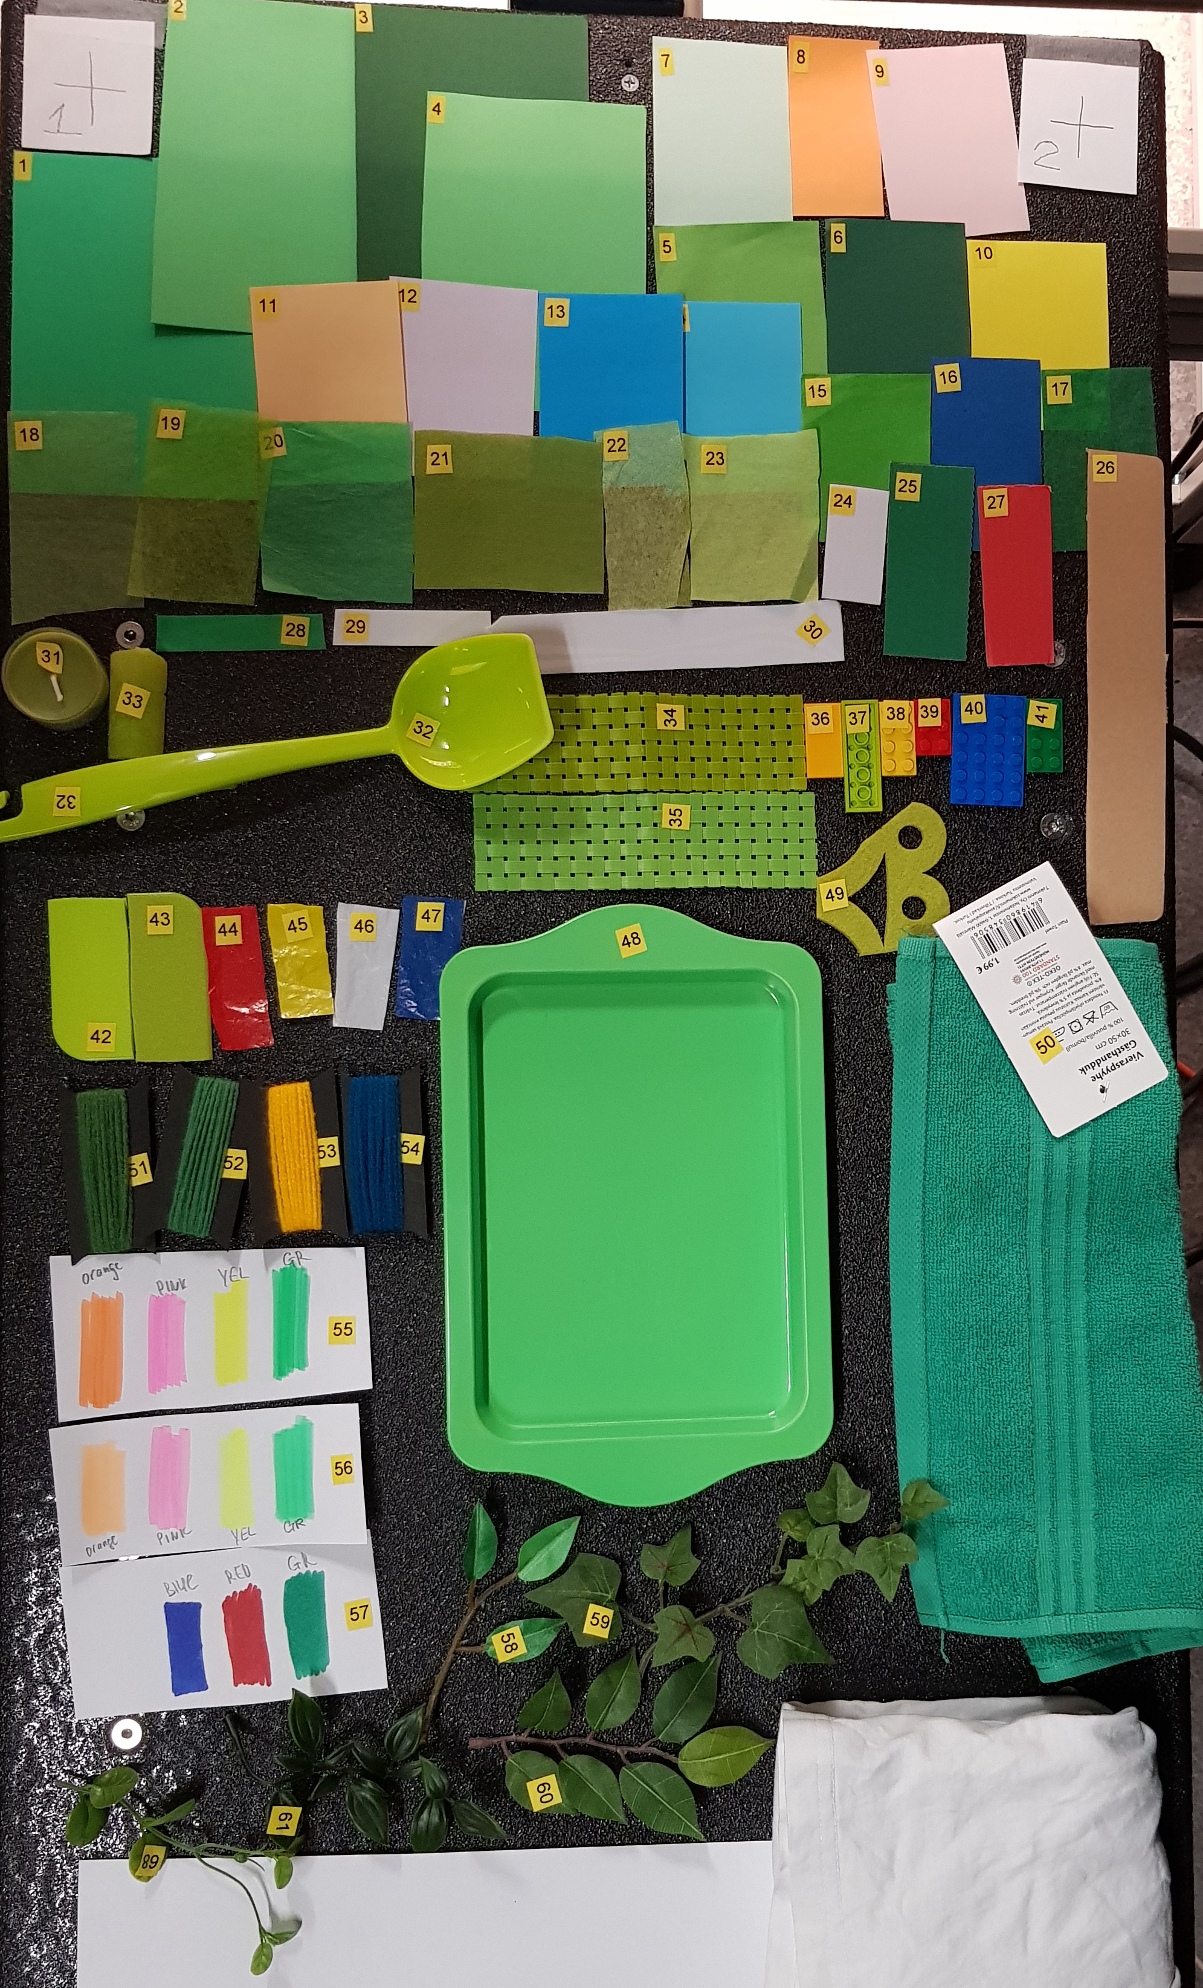

Each material (object) has a yellow-black sticker with a number. The reflectance spectrum of each object was measured with Spectrophotometer and spectra are stored in a files (shared folder ‘**LectureExercise #1, CSV\csv files**). All files are CSV files. They containg Wavelengths and Reflectance values, see picture below

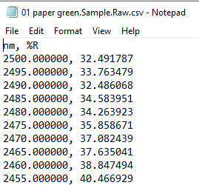

The name of files contains the information about what kind of object is it and its color, e.g. “01 paper green.Sample.Raw.csv” is green paper.

You task is to write a Python/Colab code (or use ready shared code) to open the spectra. Select several different materials and plot spectra. Select similar materials (papers) and different (paper and plastic). Compare results by plotting 2 spectra in one plot. Subtract and plot result.

You should get picture like this below. Do this for 4-5 materials.

